


17 December 2025

Funding Boost Brings Respite for Unpaid Carers in Monmouthshire

Unpaid carers in Monmouthshire will receive a welcome boost thanks to funding from the Short Breaks Scheme, aimed at offering them much-needed respite.

The Short Breaks Scheme, funded by Welsh Government and coordinated by Carers Trust Wales, awarded £10,000 to Bridges Centre, £5,000 to Gwent Parent Carers Network (GPCN) and additional funding of almost £10,000 to Adferiad. These grants will enable the organisations to deliver a range of group activities and bespoke short breaks for unpaid carers across Monmouthshire, giving them a chance to rest and recharge.

While Bridges Centre, a new recipient of the funding, was hit hard by devastating floods last month - damaging their Monmouth premises (see photo) - they remain committed to delivering their planned short breaks for carers. The funding will allow them to offer wellbeing sessions, craft activities and individualised respite breaks for up to 125 carers across the county, using alternative venues where necessary.

“We are so grateful for the funding and will continue to offer our planned Monmouth activities at alternative locations while we recover from the flood damage,” said Mike Logan Wellbeing Director from Bridges Centre. “We know that even a short break or activity can make a big impact, so our goal is to ensure carers still have access to the breaks they deserve.”
And thanks to Bridges Centre’s commitment and the Short Breaks Scheme funding, more than 80 parent carers have already been able to enjoy a couple of festive activities, including a performance of Scrooge with their children and an accessible Illumination trail—two experiences that families described as “a real lifeline.” Carers told us how being able to attend in a judgement-free, welcoming environment allowed them to truly relax, enjoy precious family time and see their children fully immersed in the activities.
One parent shared, “Being able to take both of our children to events with other families in similar situations has been a real lifeline for us. These events are wonderfully organised and come without fear of judgement by others who don't understand our situation. The relaxed atmosphere has been a great help to all of us and takes away a lot of the stress that we might otherwise feel, which in turn relaxes the children and allows us all to have fun.”
Families spoke of magical evenings “to remember forever,” the joy of seeing their children happy and confident, and the comfort of being among others with shared experiences. Several carers highlighted how these inclusive events have made a marked difference to their children’s wellbeing, helping them try new things, feel understood and build confidence—support that “means more than we could ever put into words.”

Gwent Parent Carers Network, also a new recipient of the funding, will use its £5,000 to offer respite days for parent carers across Monmouthshire, including wellness treatments and group activities aimed at reducing isolation and building resilience. GPCN fully understands the needs of parent carers as its Trustees have lived experience of being parent carers themselves. Meanwhile, Adferiad, an existing delivery provider for the scheme, has received additional funding to increase the reach of the work they are currently delivering through their current Short Breaks grant and will complement their work across the county to support unpaid carers.

Liz Wallis, Programme Lead, Carers Trust Wales, says, “We’re thrilled to support these three organisations as they deliver essential services for unpaid carers, particularly in light of the challenges faced by Bridges Centre due to the recent floods. These grants will make a real difference in Monmouthshire, where the rural geography creates unique challenges for unpaid carers.”

Welsh Government recently confirmed a significant investment over the next three years to continue supporting unpaid carers through the Short Breaks Scheme until March 2029. The scheme, launched in 2022, has already made a significant difference to the lives of unpaid carers across Wales and is on track to support 50,000 unpaid carers by March 2026. It offers access to overnight breaks, group activities, and small grants that allow carers to take time for themselves and recharge.

ENDS

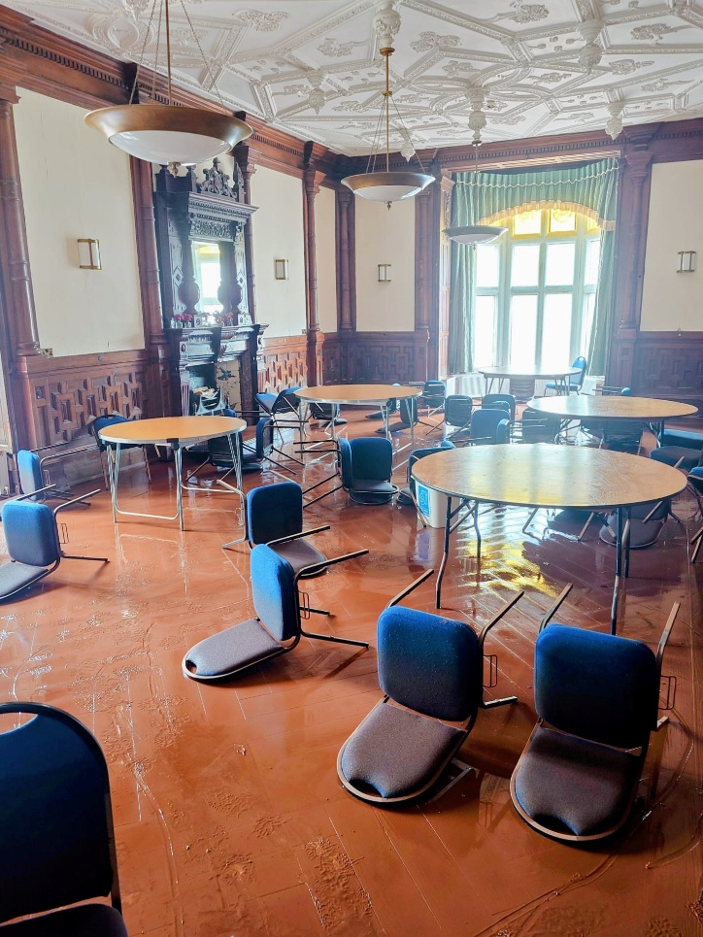
Photograph shows damage to the Bridges Centre in Monmouth after it was hit by the flooding in November 2025.

Donate here: https://www.totalgiving.co.uk/appeal/BridgesFlood

Hwb Cyllid yn Dod â Seibiant i Ofalwyr Di-dâl yn Sir Fynwy

Bydd gofalwyr di-dâl yn Sir Fynwy yn derbyn hwb croesawgar diolch i gyllid gan y Cynllun Seibiant Byr, sydd â’r nod o gynnig hoe sydd ei wir angen arnynt.

Dyfarnodd y cynllun, a ariennir gan Lywodraeth Cymru ac a gydlynir gan Ymddiriedolaeth Gofalwyr Cymru, £10,000 i Ganolfan Bridges, £5,000 i Rwydwaith Rhieni Gofalwyr Gwent a chyllid ychwanegol o bron i £10,000 i Adferiad. Bydd y grantiau hyn yn galluogi’r sefydliadau i ddarparu amrywiaeth o weithgareddau grŵp a seibiannau byr pwrpasol i ofalwyr di-dâl ledled Sir Fynwy, gan roi cyfle iddynt orffwys a chael eu cefn atynt.

Mae Canolfan Bridges yn dderbynnydd newydd o’r cyllid, ac er ei bod wedi cael ei tharo’n galed gan lifogydd dinistriol y mis diwethaf, gan achosi difrod i'w hadeilad yn Nhrefynwy, mae’n dal i fod wedi ymrwymo i ddarparu’r seibiannau byr yr oedd wedi eu cynllunio ar gyfer gofalwyr. Bydd y cyllid yn galluogi Canolfan Bridges i gynnig sesiynau llesiant, gweithgareddau crefft a seibiannau unigol i hyd at 125 o ofalwyr ar draws y sir, gan ddefnyddio lleoliadau eraill lle bo angen.

“Rydyn ni mor ddiolchgar am y cyllid a byddwn yn parhau i gynnig y gweithgareddau yr oeddem ni wedi eu cynllunio yn Nhrefynwy mewn lleoliadau eraill wrth i ni ddod dros y difrod a achoswyd gan y llifogydd,” meddai Mike Logan, Cyfarwyddwr Llesiant Canolfan Bridges. “Rydyn ni’n gwybod bod hyd yn oed seibiant byr neu weithgaredd yn gallu cael effaith fawr, felly ein nod yw sicrhau bod gofalwyr yn dal i allu cael y seibiant maen nhw’n ei haeddu.”

Bydd Rwydwaith Rhieni Gofalwyr Gwent sydd hefyd yn dderbynnydd newydd o’r cyllid, yn defnyddio ei £5,000 i gynnig diwrnodau seibiant i rieni sy’n ofalwyr ar draws Sir Fynwy, gan gynnwys triniaethau llesiant a gweithgareddau grŵp gyda’r nod o leihau unigrwydd a meithrin gwydnwch. Mae’r Rhwydwaith yn deall yn iawn anghenion rhieni sy’n ofalwyr gan fod ei Ymddiriedolwyr â phrofiad uniongyrchol o fod yn rhieni sy’n ofalwyr eu hunain. Yn y cyfamser, mae Adferiad, sydd eisoes yn ddarparwr ar gyfer y cynllun, wedi cael cyllid ychwanegol i gynyddu cyrhaeddiad y gwaith maen nhw’n ei wneud ar hyn o bryd drwy ei grant Seibiant Byr presennol a bydd yn ategu’r gwaith maen nhw’n ei wneud ar draws y sir i gefnogi gofalwyr di-dâl.

Dywedodd Liz Wallis, Arweinydd y Rhaglen, Ymddiriedolaeth Gofalwyr Cymru, “Rydyn ni’n falch iawn o gefnogi’r tri sefydliad hyn wrth iddyn nhw ddarparu gwasanaethau hanfodol i ofalwyr di-dâl, yn enwedig o ystyried yr heriau sy’n wynebu Canolfan Bridges yn sgil y llifogydd diweddar. Bydd y grantiau hyn yn gwneud gwahaniaeth go iawn yn Sir Fynwy, lle mae’r ddaearyddiaeth wledig yn creu heriau unigryw i ofalwyr di-dâl.”

Yn ddiweddar, cadarnhaodd Llywodraeth Cymru fuddsoddiad sylweddol dros y tair blynedd nesaf i barhau i gefnogi gofalwyr di-dâl drwy’r Cynllun Seibiant Byr tan fis Mawrth 2029. Mae’r cynllun, a lansiwyd yn 2022, eisoes wedi gwneud gwahaniaeth sylweddol i fywydau gofalwyr di-dâl ledled Cymru ac mae ar y trywydd iawn i gefnogi 50,000 o ofalwyr di-dâl erbyn mis Mawrth 2026. Mae’n cynnig mynediad at wyliau dros nos, gweithgareddau grŵp, a grantiau bach sy’n galluogi i ofalwyr gymryd amser iddyn nhw eu hunain a chael eu cefn atynt.
Mae'r ffotograff yn dangos y difrod i Ganolfan y Pontydd yn Nhrefynwy ar ôl iddi gael ei tharo gan y llifogydd ym mis Tachwedd 2025.

Notes to Editors

About Carers Trust Wales

Carers Trust Wales, part of Carers Trust, aims to shape a better future with and for carers in Wales by raising awareness, empowering carers and influencing change. It is committed to making sure that all carers receive the recognition and support they deserve. It works closely and collaboratively with Network Partners – local and regional independent charities which deliver information, advice and practical support for unpaid carers in Wales.

Carers Trust website: www.carers.org

About the Short Breaks Scheme
Management of the Short Breaks Scheme is shared between Carers Trust Wales and seven Regional Partnership Boards. Orgnisations apply for the funding to deliver the activities.

The Short Breaks Scheme was launched in 2022 to support 30,000 unpaid carers from across Wales to take a much-needed break from their caring responsibilities by 2025. Thanks to continued funding from Welsh Government, it now runs until 2029. Carers Trust Wales is the National Coordinating body of the scheme, distributing grants to charities and Third Sector organisations across Wales.

Short Breaks Scheme website: www.shortbreaksscheme.wales

Contact: Jude Wood: jwood@carers.org

